**D.Y.PATIL COLLEGE OF ENGINEERING & TECHNOLOGY,**

**KASABA BAWADA, KOLHAPUR**

**DEPARTMENT OF COMPUTER SCIENCE & ENGINEERING**

**(2020-2021)**



**A**

**Mini Project**

**Report on**

**“Student management system”**

**Submitted by:**

**Roll No. Name of Student**

**1 Siddharth Gharge**

**2 Hrishikesh Patil**

**3 Manasi Mandlik**

**4 Stalin Tondale**

**Under the guidance of**

**Mrs. R. S. Jadhav**

**Class: SY(CSE) Div.:A Batch: G1**

**1. INTRODUCTION:**

**Our project is a student management system project. It includes all details about a syudent studying in college such as his/her admission info,admission type,courses he/she have enrolled in,etc.**

**2. AIM :**

**To provide a platform for handling students data and their academic progress.**

**3. MODULES OF THE PROJECT :**

**1)Student information (Name,address,mobile number,email:int/char type)**

**2) file for storing students data**

**3)Enrollment number:long type**

**4)course:char type**

**5)branch:char type**

**4.EXPLANATION :**

**Basic functioning of the system is registering the students, storing record of currently studying students ,deleting or arranging records of previously passout students.This system only allows faculties to authorize this data with a protected password and username.This project helps to create database of students studying in any organization or institute so it will no more tideous task to college /university faculties to maintain students information in various files or creating separate files to each of them.**

**5.Algorithm/pseudo code –**

**1)start**

**2)Input student info using structure.**

**Input:Name,Roll_no,Department_name,sgpa for 12 semisters.**

**3)Create database using files and login and save password using password() function.**

**4)Enter tasks to perform using switch case in main() function.**

**Add_student(),modify_student(),show_all_students(),Individual_view(),remove_student(),attendance(),change_password(),logout().**

**5)Input functions by giving choice in switch case.**

**6)i)void password(){char c;**

**Printf(“enter password”);**

**Gets(pa.pass);**

**Scanf(“%c”,&c);**

**If(c==’y’ || c==’Y’)**

**{**

**//writing data into file and close file**

**Printf(“\npassword saved”);**

**}}**

**ii)Add_student()**

**{//input student data and writing it into file**

**//after inputting one student add printf to print another student info**

**using char value}**

**iii)Modify_student()**

**{**

**Printf(“\nenter student roll_no for updating student info”);**

**//rewind file pointer and read data from file and create a temp variable and flag to compare the actual file info**

**//After getting student info update it with new info and save changes and write changes into file**

**}**

**iv)show_all_students()**

**{**

**//function to display all students data**

**//rewind file pointer and read data from file and display data**

**}**

**v)Individual_view()**

**{//input char datatype to input our choice of roll_no and compare it with struct data**

**//use wile loop with condition of our input char repeat same steps of iv)for individual_view.**

**}**

**vi)Remove_student()**

**{**

**//create a temporary file pointer to store current data from original file**

**//rewind original file and read data from file and enter roll_no of student to delete info and repeat steps of v)steps .**

**//close both files and remove original file and rename temp file as original file and save data into it.**

**}**

**vii)Attendance()**

**{**

**//Attendance function to calculate student attendance**

**//Storing attendance of student using class**

**Input:**

**Int enter();**

**Void calculate();**

**Void display_all();**

**Void write _attendance();**

**//accessing above functions using switch case**

**a)int enter()**

**{**

**Input:date,month,year**

**Int i,n,k,a,c //variables to store attendance of particular date and for setting flags according to that.**

**//using while loop and switch case for checking if date is correct or not.**

**While(1)**

**{**

**Printf(“\n input date/month/year”);**

**If(month==1||3||5||7||8||10||12){if(date>31 || date==0)**

**c=0;**

**else //if statement to update correct according to month and no of days in month.**

**c=1;**

**}}**

**If(month==4||6||9||11){**

**If(date>30 || date ==0)**

**{c=0;**

**else**

**c=1;**

**}}**

**if(month>12){c=0;} // for invalid condition**

**if(month==0 || year ==0)**

**{**

**c=0;}}//while loop ends here.**

**//using switch case to check if date is valid or not.**

**//input no of periods in a day**

**For(k=1;k<n+1;k++) //using for loop to update all periods attendance**

**{//enter 1 to present and 0 to absent**

**If(a==1)**

**p++,t++,z[k]=1;**

**else**

**t++,z[k]=0;**

**//update attendance of student and store it in array data structure and increment the values to point to next values.**

**printf(“updated as present/absent “);}**

**//repeat for above loop upto n iterations to update attendance of the day.**

**//enter int 1 input to update another day attendance else input 0 .**

**//attendance enter function finished.**

**}**

**b)void calculate()**

**{**

**//calculating attendance percentage according to classes attended by students**

**Int x,r; //integers for storing calculation data**

**float s;**

**x=(t*75)*100; //formulas to calculate overall attendance and calculate percentage**

**s=(p*100)/t;**

**//checking if conditions to check attendance entered**

**If(s<75 && s>65){**

**Printf(“\nlow attendance”);**

**If(s<65)**

**{**

**y=(t*65)/100; //attendance percentage calculation**

**printf(“\nyour attendance is”,s%);**

**//calculate function ends here**

**} //attendance function ends here**

**viii)stop**

**6.CONCLUSION –**

**This system is smooth,feasible and user_friendly and efficient way of searching and sorting data.**

**7.REFERENCES –**

**i) https://Geeksforgeeks.org**

**ii) c tutorials from -** [**https://www.w3schools.in/c-tutorial/**](https://www.w3schools.in/c-tutorial/)

**8.DFD(DATA FLOW DIAGRAM)-**

Admin

Request to Add student data

Insert student data and reply db.txt

Request to modify student data

modify student data and reply

db.txt

Request to show all students data

Show students data and reply db.txt

Request to get individual view

show individual view and reply

db.txt

Request to remove student Remove student data and response

storing all info in temp.txt and deleted info in db.txt and rename files after operation

Request to change password change password and response to request

password.txt

Request for logout and response Response for logout

**9)screenshots of program :**

**i)Home menu and Add_student function:**

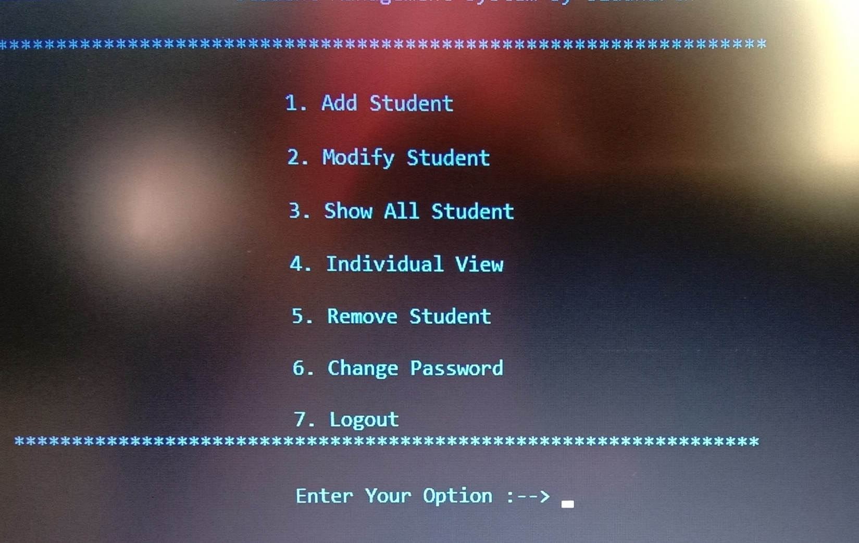

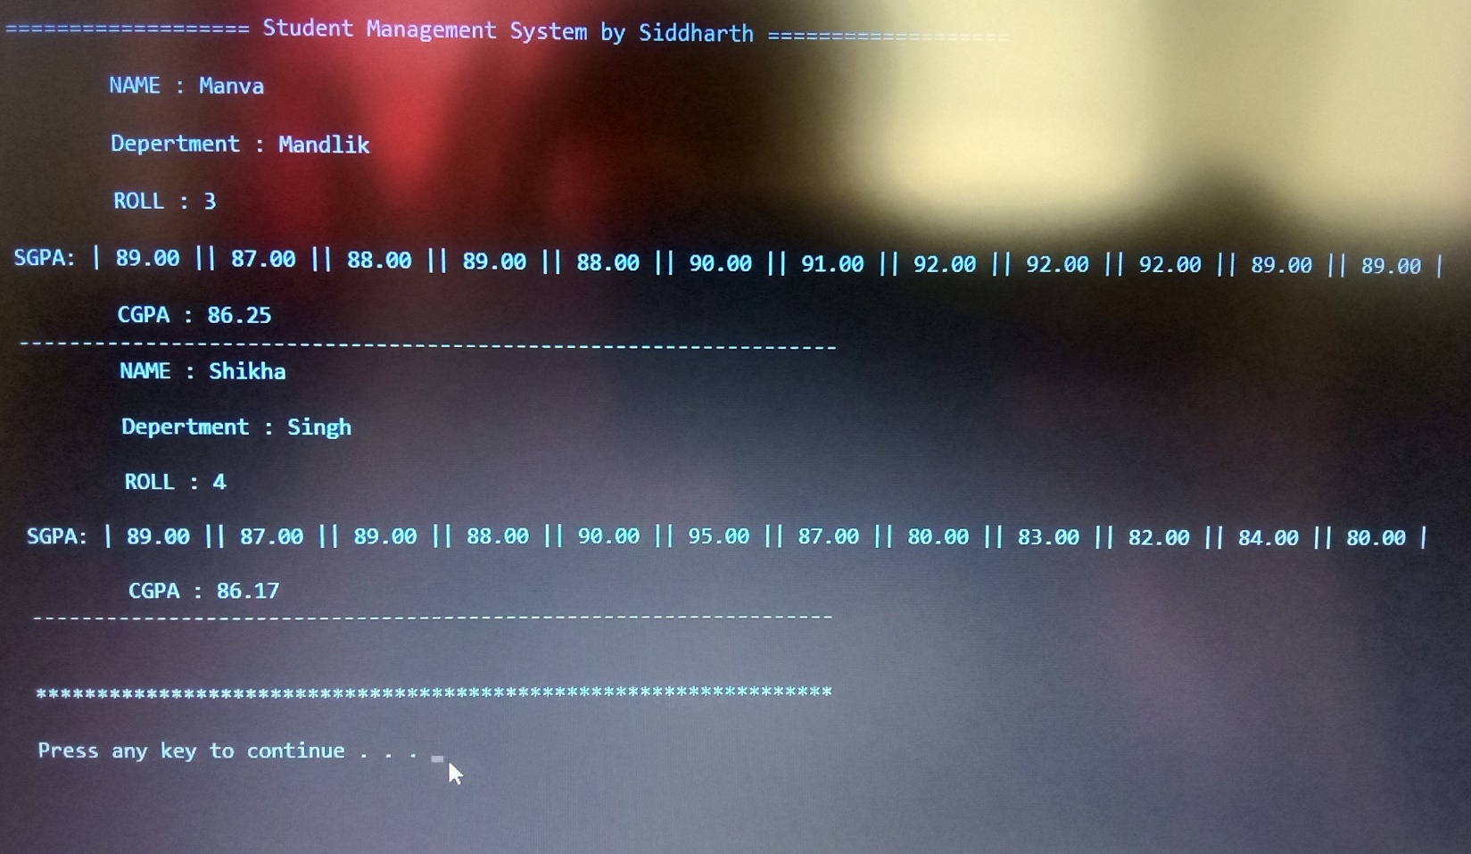

**ii)Delete student and modify student function:**

